**Demonstrate how test scripts are written in Postman**

Step-1:

First I open postman

Step-2:

Then I create a get request and rename it , also give url

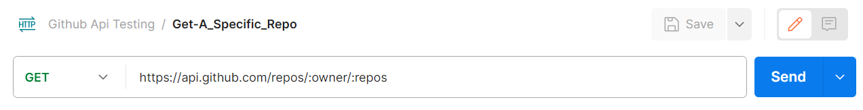

Step-3:

Here I write some test script to validate

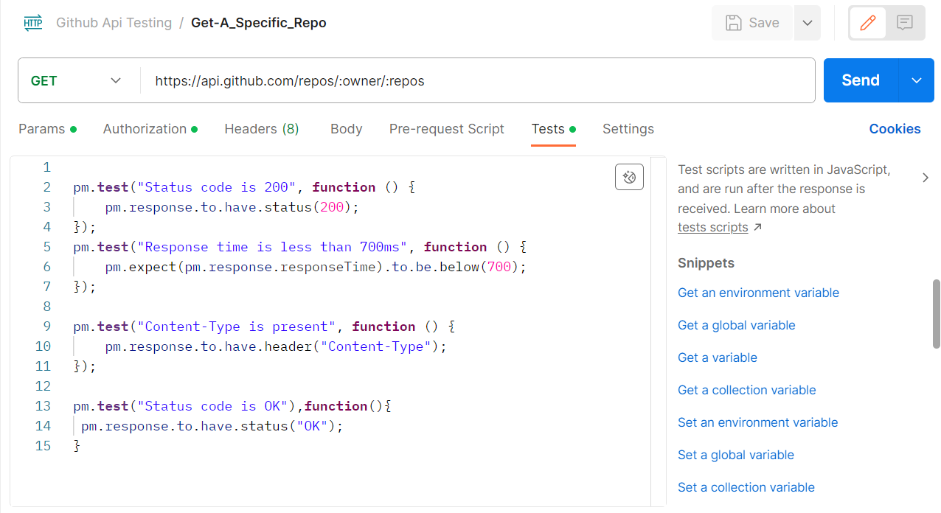

Step-4:

Then I save it and click on send

